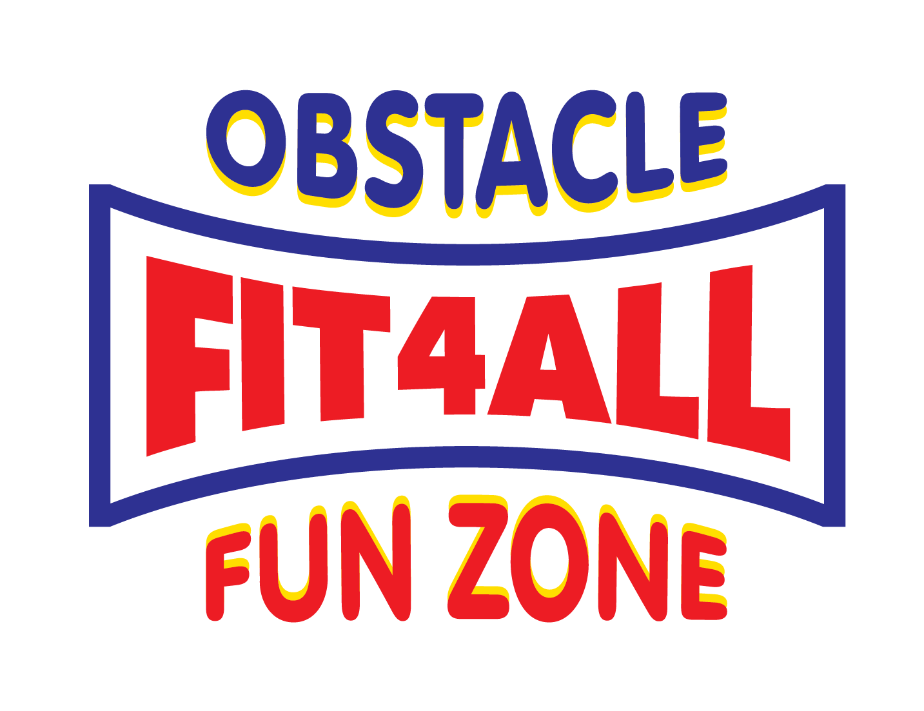
OBSTACLE FUN ZONE
Risk Assessment Record
Ref No: |  |  | Faculty/dept | FIT 4 ALL
Date of assessment: |  | 5/5/18 | Section: | OBSTACLE FUN ZONE
Assessment team: |  | MILTON KARAVAS/EFFIE KARAVAS
Identify/describe activity, equipment, area or event you are assessing:

Item | Step 1:  Identify the hazard/s | Step 2: Assess the risks - Note there may be several risks associated with each hazard  List the Consequence (how bad would it be?), Likelihood & Risk rating for each risk .  Refer to Risk Matrix | Step 3 & 4: List the controls needed to remove or reduce the risks and record the date additional controls are completed or due for completion. | Step 5: How will the risk be monitored and who has the responsibility?  Record review date

 | What could cause harm? | What could go wrong? | C | L | R | Controls | Date  completed | Review method & position/ person responsible | Review  Date
1 | EMERGENCY RESPONSE | FIRE  ELECTRICAL SAFETY ISSUE | 5 | 4 | 4 | FIRE EXTINGUISHER  FIRE REEL  REGULAR TRAINING ON PROCEDURE | 1/5/18 | RAINE & HORNE  COMMERCIAL
2 | ACCESS TO SITE | VEHICLE MOVEMENT IN CAR PARK/HIT BY MOTOR VEHICLE  TRIPPING ON UNEVEN GROUND | 3 | 3 | 3 | CONTROL OF CHILDREN ENTERING & EXITING CENTRE  Supervisors of children to control  movements to front door and into centre  - Facility inspection to include access and  egress to and from building and premises as a whole  - Centre manager to report any unsafe footpath or nature strip issues to their local council and Raine & Horne Commercial. |  | RAINE & HORNE  COMMERCIAL  FIT 4 ALL MANAGEMENT
3 | SECURITY OF CHILDREN IN PLAY AREA | WANDERING CHILDREN  CHILDREN LEAVING PLAYGROUND | 2 | 2 | 2 | Fit 4 All Supervision Guidelines to  be followed by supervisors  - Nets to be secured to prevent egress from  within the courts, with the exception of the  main entry / exit into the playground area  - Emergency response established for  missing child procedures and staff trained |  | STAFF FIT 4 ALL
4 | INFLATABLE PLAYGROUND EQUIPMENT | - Child gets caught in  deflating equipment  - Child gets stuck between  two inflatables  - Patron accessing blowers  and switching them off | 3 | 3 | 3 | Emergency Response established for  deflating inflatable.  - Staff trained in the procedure for responding  to deflating equipment  - Staff to monitor and prevent children attempting to squeeze between inflatables  - Blowers in public areas to be covered by the blower covers.  - Staff to monitor movement around any accessible blowers. |  | FIT 4 ALL STAFF
5 | INFLATABLE PLAYGROUND EQUIPMENT | Falling while exiting inflatable  - Falling over the side of inflatable  - Generally falling through loss of balance  - Jumping and falling awkwardly  - Flipping / Somersaults  (prohibited activity)  - Sliding  - Body collision  Injuries results such as:  - Contusions/Bruising/Burns  - Fractures  - Concussion  - Bleeding/Sprain / Strain  - Heat Illness  - Infections  - Heart Attack/Stroke  - Asthma attack | 2 | 2 | 4 | Safety Video provided and requirement to be watched prior to entry.  - Safety Video available on website  - Verbal safety message provided on entry  - Thick landing mat provided at entrance and exit of all equipment  - Number of players on each item is displayed  on equipment and monitored and enforced by floor staff  - Specific equipment has full time floor staff monitoring equipment when in use  - Flipping is a prohibited activity on all equipment  - Bullying and aggressive behaviour is prohibited activity and offenders will be REMOVED. |  | FIT 4 ALL  STAFF
6 |  | Overcrowding on  Inflatable equipment  - Weight limit per individual  Exceeded removed |  |  |  | Signage provided throughout courts on  safety requirements  - Regular cleaning of equipment with hot soapy water  - IWOS inspections include visual inspection  of all parts of the inflatable  - Silicone spray used on slides to protect  surface and decrease friction  - First Aid Officer on duty every shift  - Staff trained in asthma emergency  - Weight limits clearly marked and signed throughout centre and on inflatables  - Staff training provided on identifying and questioning if people are over the weight  limits and enforcing the safety rules |  | FIT 4 ALL  STAFF  Parent Supervision
7 | CHILDREN GENERAL PLAY | Trip and fall  - Over heating and potential  for heat related illness  - Dehydration  - Over excited due to  excessive sugar / energy | 2 | 2 | 2 | Staff trained in identification of heat related illness  - Children monitored by parents / supervisors  to have regular breaks and drinking water to  rehydrate  - Limit the amount of sugar intake to assist |  | FIT 4 ALL  STAFF  Parent Supervision
8 | PARENTAL SUPERVISION REQUIREMENTS | Parents not actively supervising young children  Children being left in centre without supervision  Children injured or lost  - Child causing injuries to  others | 3 | 2 | 4 | Parental supervision requirements clearly posted around the centre and included in safety message on entry  - Unsupervised young children brought to front counter as ‘lost’, requiring PA message  to parent  - Communication to be used to get assistance from staff in the case of lost children  - Unaccompanied underage children kept at  front counter until parent returns to centre |  | FIT 4 ALL  STAFF  Parent Supervision
9 | CHILDREN WITH SPECIAL NEEDS  Considered  independently with  child supervisor / parent | Distress to child from  noise, activity  - Injuries  - Damage to inflatables | 2 | 2 | 2 | To be determined based upon individual assessment of child’s requirements.  - Parent or carer to remain with child at all times while in centre. |  | FIT 4 ALL  STAFF  Parent Supervision
10 | COMMUNAL AREAS | Trip and fall  - Body collisions  - Hot drink spills  - Fluid spills  Injury to persons where  first aid attention is required to be administered |  |  |  | Centre Manger and Supervisor to monitor and control patrons and their children’s activities  - Communication to be used to get assistance from staff in the case of unwanted behaviour. |  | FIT 4 ALL  STAFF  Parent Supervision

Risk Assessment Matrix
This matrix and risk score system helps determine priority for corrective action.
- Consider what can go wrong
- Determine how bad the outcome would be - Consequences
- Determine how likely it is to happen - Likelihood
- Calculate the risk level

LIKELIHOOD   | CONSEQUENCES
LIKELIHOOD   | Catastrophic  5 | Major  4 | Moderate  3 | Minor  2 | Insignificant  1
Almost certain 5 | 10 | 9 | 8 | 7 | 6
Likely  4 | 9 | 8 | 7 | 6 | 5
Possible  3 | 8 | 7 | 6 | 5 | 4
Unlikely  2 | 7 | 6 | 5 | 4 | 3
Rare  1 | 6 | 5 | 4 | 3 | 2

CONSEQUENCES: How severely could it hurt someone/cause damage?
Catastrophic death or large number of serious injuries, environmental disaster, huge cost
Major serious injury, extensive injuries, severe environmental damage, major cost
Moderate medical treatment required, contained environmental impact, high cost
Minor first aid treatment required, some environmental and/or financial impact
Insignificant No injuries, low financial/environmental impact

LIKELIHOOD: How likely is it to happen?
Almost Certain expected to occur in most circumstances
Likely will probably occur in most circumstances
Possible might possibly occur at some time
Unlikely could occur at some time
Rare may occur only in exceptional circumstances

Risk Score |  | What should I do?
9-10 | Extreme | Immediate action required
7-8 | High | Action plan required, senior management attention needed
5-6 | Moderate | Specific monitoring or procedures required, management responsibility must be specified
2-4 | Low | Manage through routine procedures

