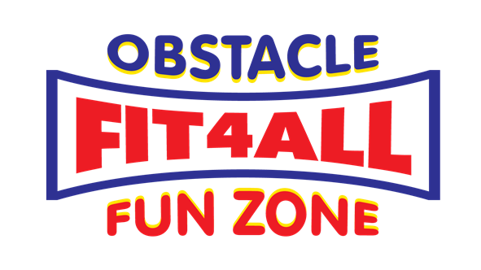

**FUNCTION CANCELLATION POLICY**

While Fit 4 All staff are passionate about providing a Fun Party for all, our main priority is always safety. So we have some safety guidelines we must adhere to in order to ensure a safe and fun party. Below are some of the guidelines we utlise to ensure that is achievable.

**Weather** – Without doubt having an amazing outdoor facility is not without it’s difficulty and one of those is the weather a factor we obviously can’t control.

**High Winds** – Whilst protected by the building itself high winds above 40kh will create significant safety issues and whilst Inflatables have fixing points we will provide 24 hours notice if weather is inappropriate.

**Rain** – Inflatables can be operated in light rain and although it increases the injury risks without doubt we can still provide shelter for spectators and party can go ahead pending prerogative of party booking.

**Heat** – Extreme in any outdoor setting can pose safety issues for anybody however the nature of physical activity and extreme heat can be dangerous. Appropriate shelter for spectators will be provided however precaution with regard to hydration to prevent heat stroke is strongly recommended.

**NOTE : Should you wish to cancel your booking we respectfully ask you provide 14 days notice for refund alternatively date can be provided.**